# Emerging Methods for Early Detection of

# Forest Fires

**Submitted by**

# BALAJI P (513419104006)

# DEEPACH CHANDRU M (513419104010)

# DEEPAK RAJ T (513419104011)

# DHINESH BABU H (513419104012)

**in partial fulfilment of the requirements for the award of the degree**

**of**

BACHELOR OF ENGINEERING

***in***

# COMPUTER SCIENCE AND ENGINEERING

**UNIVERSITY COLLEGE OF ENGINEERING**

**KANCHEEPURAM**

# 

**ANNA UNIVERSITY: CHENNAI DECEMBER 2022**

**INDEX**

1. **INTRODUCTION 4**
   1. Project Overview
   2. Purpose
2. **LITERATURE SURVEY 5**
   1. Existing problem
   2. References
   3. Problem Statement Definition
3. **IDEATION & PROPOSED SOLUTION 7**
   1. Empathy Map Canvas
   2. Ideation & Brainstorming
   3. Proposed Solution
   4. Problem Solution fit
4. **REQUIREMENT ANALYSIS 12**
   1. Functional requirement
   2. Non-Functional requirements
5. **PROJECT DESIGN 16**
   1. Data Flow Diagrams
   2. Solution & Technical Architecture
   3. User Stories
6. **PROJECT PLANNING & SCHEDULING 19**
   1. Sprint Planning & Estimation
   2. Sprint Delivery Schedule
   3. Reports from JIRA
7. **CODING & SOLUTIONING (Explain the features added in the project along with code) 21**
   1. Feature 1
   2. Feature 2
8. **TESTING 28**
   1. Test Cases
   2. User Acceptance Testing
9. **RESULTS 30**
   1. Performance Metrics
10. **ADVANTAGES & DISADVANTAGES 35**
11. **CONCLUSION 36**
12. **FUTURE SCOPE 36**
13. **APPENDIX 37**

Source Code

GitHub & Project Demo Link

# CHAPTER 1

# INTRODUCTION

**1.1 Project Overview**

Forests keep the ecological equilibrium in check. It serves as a setting that enhances the diversity of different creatures. The project's goal is to find forest fires as quickly as possible so that we can protect the numerous species that live there from the fire. Fire detection can be quite difficult using the currently available methods of smokesensors installed in the buildings. They are expensive and slow because of their old technology and design. In this study, artificial intelligence's application for CCTV film identification and alerting is critically reviewed. A self-created dataset of videoframes containing fire is utilised for this project. After preprocessing the data, CNN is used to create a machine learning model. The approach is tested on the test set of the dataset, and experiments are documented. The project's objective is to develop a device that can be used in virtually every fire detection circumstance, is very accurate, and is both economical.

### Purpose

Forests are one of the most important factors in maintaining ecological balance. It can be highly dangerous when a fire starts in a forest. A forest fire is usually only detected after it has burned a sizable amount of land, though. The fire might not always be extinguished by it. The environmental impact is worse than expected as a result. Large-scale carbon dioxide (CO2) emissions from the forest fire have a negative impact on the ecosystem. Rare species would end up going extinct globally as a result. In addition, it might affect the weather, which might result in dangerous issues like earthquakes, too much rain, floods, and so forth. The forest is a sizable area that is covered in trees, tonnes of dried leaves, forests, and other vegetation. These things are what start the fire and make it grow. A fire may start for a number of reasons, such as smoking, fireworks display, or hot summer days. Once a fire begins, it won't go out until it has completely consumed itself. The damage and expenses related to detecting it because of a forest fire can be

minimised when the fire is discovered as soon as is practical. Fire detection is therefore essential

in this situation. Finding the exact location of the fire and alerting the fire department as soon as it starts can have a positive impact. Therefore, it is essential to put in place a system to spot fire.

**CHAPTER 2**

**LITERATURE SURVEY**

**2.1 EXISTING PROBLEM**

Fires are discovered using heat and smoke alarms. The main flaw with smoke sensor alarms and heat sensor alarms is that one module cannot monitor all of the areas that could catch fire. The only way to prevent a fire is to always be cautious. To consistently create an efficient output, they simply cannot be fitted in every nook and cranny. The cost will increase by a factor of multiples as the necessary number of smoke sensors increases. The suggested approach can produce trustworthy and extremely precise alerts within seconds of an accident or a fire. The entire surveillance network is powered by a single piece of software, which reduces costs. Experts in machinelearning and datascience are now working on this project.

**2.2 REFERENCES**

[1] Visit the European Forest Fire Information System's official website at <http://effis.jrc.ec.europa.eu>

[2] Visit the Copernicus Earth Observation Program's official website at <http://www.copernicus.eu.>

[3] Forest Fires in Europe, the Middle East, and North Africa 2016, JRC Science for Policy Report, BN 978-92-79-71292-0, ISSN 1831-9424, doi:10.2760/17690, accessible at: [http://effis.jrc.ec.europa.eu/media/cms](http://effis.jrc.ec.europa.eu/media/cms%20) page media/40/Forest fires i n Europe Middle East and North Africa 2016 final_

[4] Visit the Wikipedia entry for the 2018 Attica wildfires at [https://en.wikipedia.org/wiki/2018Atticwildfires](https://en.wikipedia.org/wiki/2018%20Atticwildfires).

[5] Visit the ALTi Transition VTOL UAV's official website at: <https://www.altiuas.com/transition/>

[6] Visit the DJI Matrice 600 Pro UAV's official website at <https://www.dji.com/matrice600-pro>

[7] The DJI Matrice 200 series of UAVs has an official website at <https://www.dji.com/matrice-200-series.>

[8] Visit Movidius's official website at <https://www.movidius.com>.

[9] The IMST iC880A LoRaWAN concentrator's official website may be found at https://wireless-solutions.de/products/long-range-radio/ic880a.html.

**2.1 PROBLEM STATE DEFINITION**

* Forest fires have a variety of detrimental effects, such as the destruction of wildlife habitat.
* The extinction of plants and animals, the destruction of nutrient-rich top soil, the reduction of forest cover, the loss of valuable timber resources, the destruction of the ozone layer.
* The loss of livelihood for tribal and low-income people, the acceleration of global warming, the increase in atmospheric carbon dioxide concentration, the degradation of catchment areas, the loss of valuable timber
* Resources, and the loss of valuable biodiversity.Create a system that uses the most recent technologies to identify forest fires as early as possible.

**CHAPTER 3**

**IDEATION AND PROPOSED SOLUTION**

**3.1 EMPATHY MAP CANVASS**

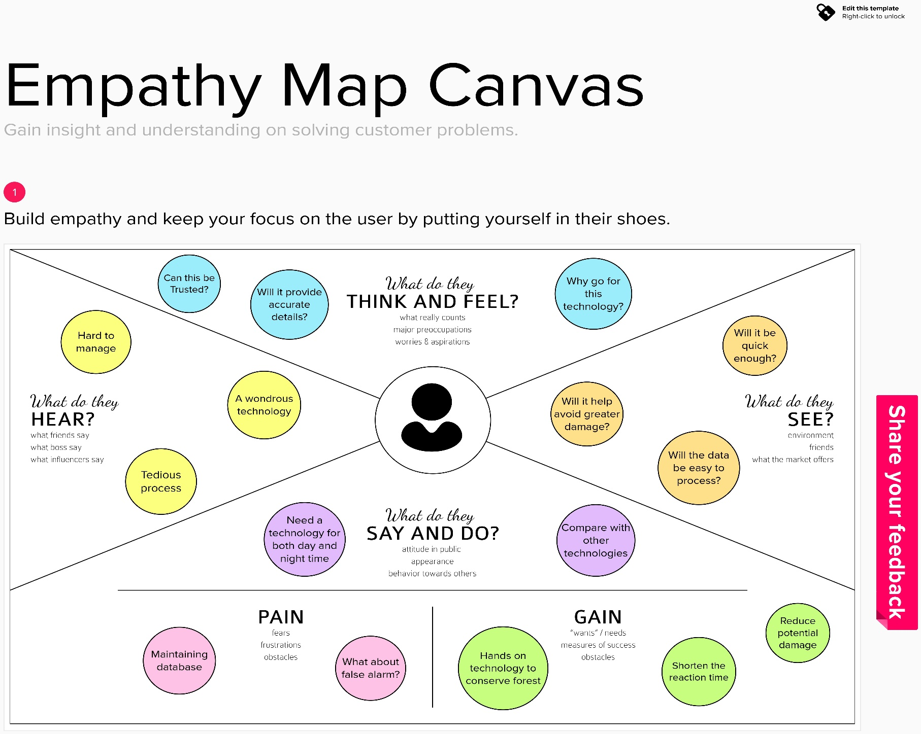An empathy map is a straightforward, simple-to-understand picture that summarises information about a user's actions and views. It is a helpful tool to aid teams in comprehending their users. It's important to comprehend both the actual issue and the person who is experiencing it in order to develop a workable solution. Participants learn to think about issues from the user's perspective, as well as his or her objectives and challenges, through the exercise of creating the map**.**

**3.2 IDEATION AND BRAINSTORMING**

During a brainstorming session, everyone on a team is encouraged to engage in the process of original thought that results in problem solving. Volume over quality is prioritised, unconventional ideas are welcomed and developed upon, and everyone is urged to participate in order to produce a wealth of original solutions.

**Step 1:**

**Step 2:**

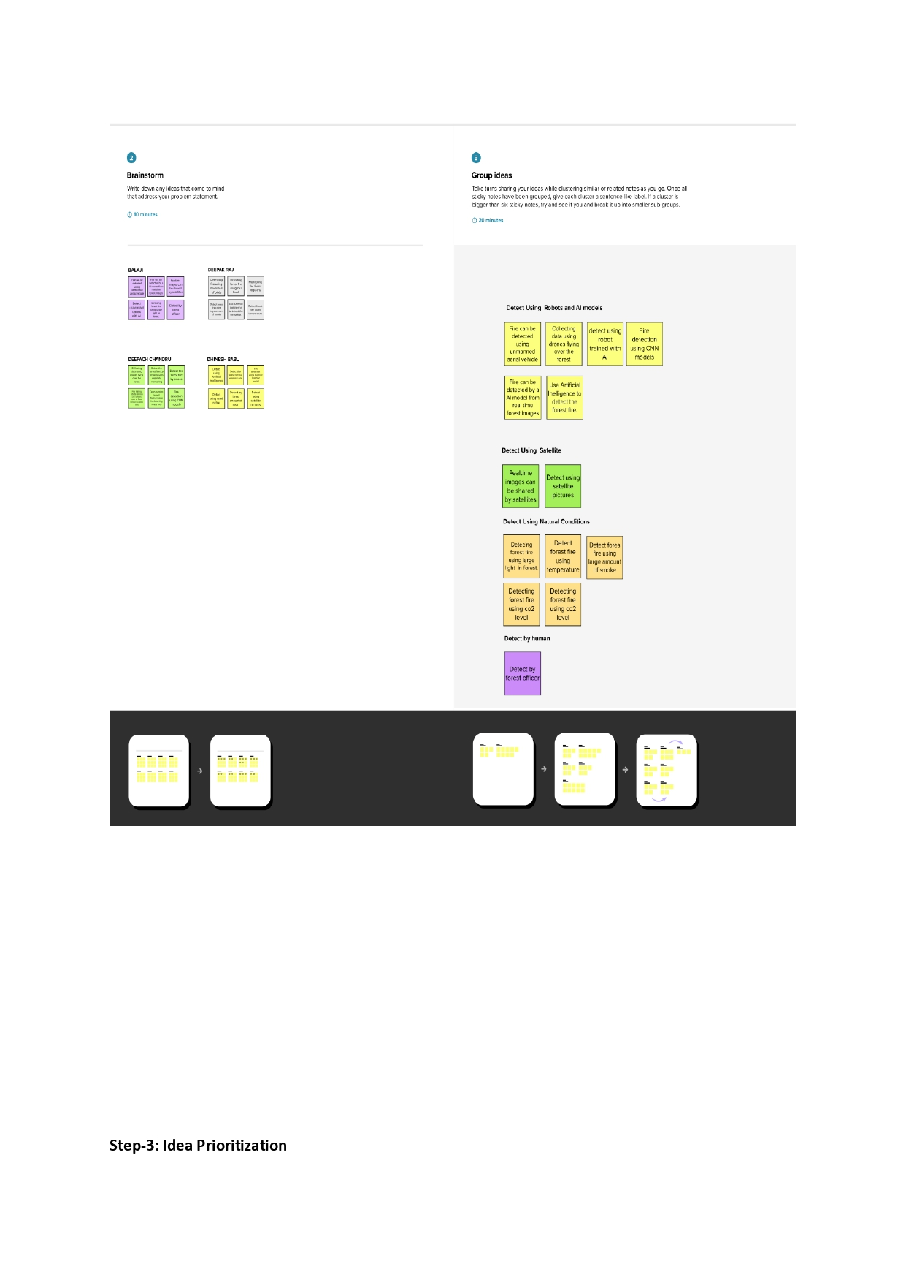

**Step 3:**

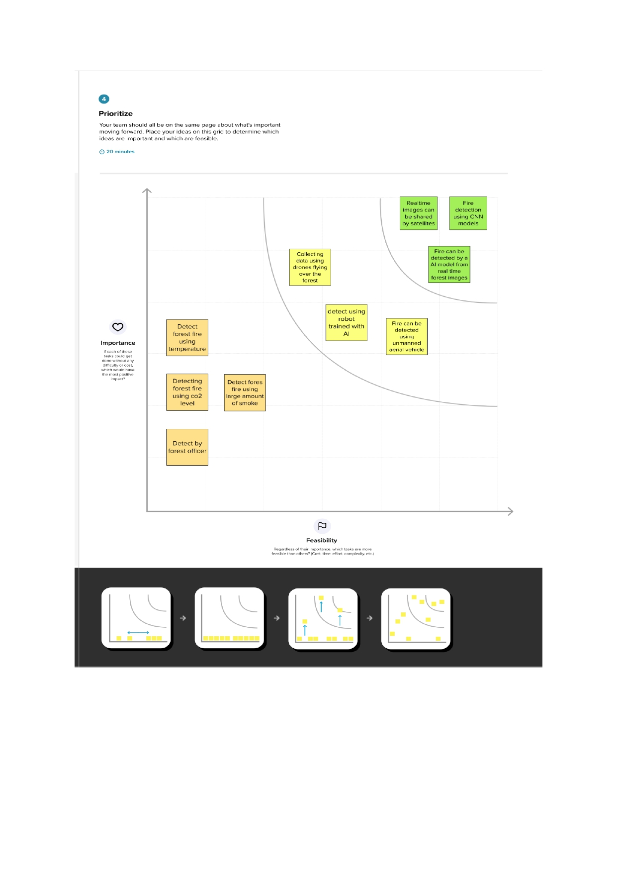

**3.3 PROPOSED SOLUTION**

|  |  |  |
| --- | --- | --- |
| **S. No** | **Parameter** | **Description** |
| 1. | Problem Statement (Problem to be solved) | Detect forest fires at an earlier and inform the local fire authorities. |
| 2. | Idea/Solution Description | Fire can be detected from real time – images shared via satellite. |
| 3. | Novelty/Uniqueness | It’s difficult to predict and detect Forest Fire in a sparsely populated forest area and it’s more difficult if the prediction is  done using ground-based methods like camera or video-based approach. satellite can be important source of data prior to and during the Fire due to its reliability and efficiency. |
| 4. | Social Impact/Customer Satisfaction | According to WHO Wildfires affected 6.2 million people between 1998-2017 with 2400 attributable death worldwide from suffocation, injuries, and burns, but the size and frequency of wildfires are growing due to the climate change. Wildfires also simultaneously impact weather and climate by releasing large quantities of CO2, CO and fine particulate matter into the atmosphere. Resulting air pollution can cause a range of health issues, including respiratory and cardiovascular  Problems. By implementing the proposed solution, people from various walks of life gets impacted and will attain customer satisfaction at its best. |
| 5. | Business model | Exploratory data analysis report and data dashboard services  Can be provided using subscription-based model through which Revenue can be generated. |
| 6. | Scalability of the Solution | Forest Fires results in various impacts on wildlife, humans and the environment. hence the proposed solution can be scaled to detect forest fires at early stage to prevent huge disaster. |

**3.4 PROBLEM SOLUTION FIT**

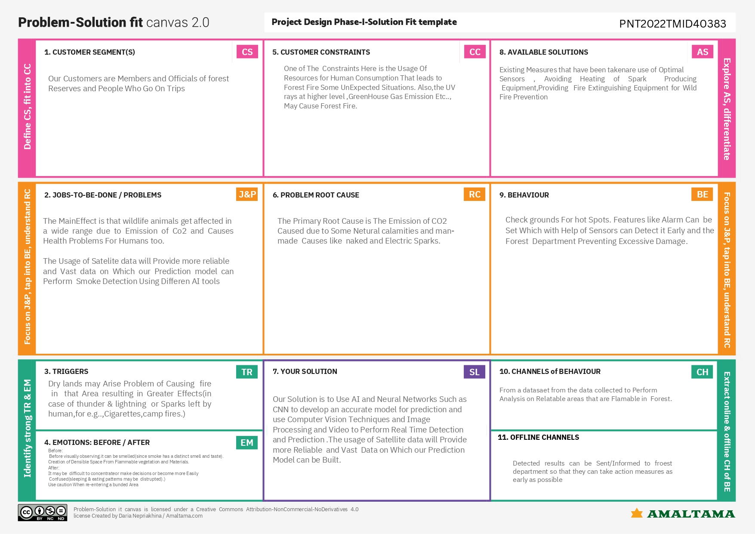

CHAPTER 4

**REQUIREMENT ANALYSIS**

**4.1 FUNCTIONAL REQUIREMENTS**

Following are the functional requirements of the proposed solution.

|  |  |  |
| --- | --- | --- |
| **FR NO.** | **Functional Requirement** | **Sub Requirement (Story/Sub-task)** |
| FR-1 | User Registration | Registration through Form  Registration through Email |
| FR-2 | User Confirmation | Confirmation via Email  Confirmation via OTP |
| FR-3 | Authentication | Throughs OTPs or OAuth |
| FR-4 | User-Monitoring | Prediction using Artificial Intelligence  Live status of Patches of Forests |
| FR-5 | GPS - Tracking | Track the location |
| FR-6 | Administrative function | Preserving, Restoring, Maintaining of species |

**4.2 NON-FUNCTIONAL REQUIREMENTS**

Following are the Non-Functional requirements of the proposed solution.

|  |  |  |
| --- | --- | --- |
| **FR NO.** | **Non-Functional Requirement** | **Description** |
| NFR-1 | Usability | * Our Solution is intended for forest officers, biologist, naturalist, Ecologist with the goal of protect forests. |
| NFR-2 | Security | * Good encryption, Authentication and authorization. |
| NFR-3 | Reliability | * Framework for creating digital devices that supports the flora and Fauna in forests. |
| NFR-4 | Performance | * Transfer learning approach to improve accuracy and performance of the application. |
| NFR-5 | Availability | * Application will also work on the office to notify user through messages. |
| NFR-6 | Scalability | * With help of cloud services, a greater number of users can access the application |

# CHAPTER 5

**PROJECT DESIGN**

* 1. **Data Flow Diagrams**

#### The classic visual representation of how information moves through a system is a data flow diagram (DFD). A tidy and understandable DFD can graphically represent the appropriate quantity of the system demand. It demonstrates how information enters and exits the system, what modifies the data, and where information is kept.

#### FLOW:

* + - In a sparsely inhabited forest area, it is challenging to anticipate and detect forest fires. It becomes even more challenging if the prediction is made using ground-based techniques like camera or video-based approaches.
    - The numerous real-time forest fire detection and prediction systems, with an aim of informing the local fire authorities. Satellites, which can be a reliable and efficient source of data both before and during the Fire.
    - It will communicate the outcome to the frame camera if the fire is not detected. The video stream frame camera will receive a warning if a forest fire is discovered.

**DIAGRAM**

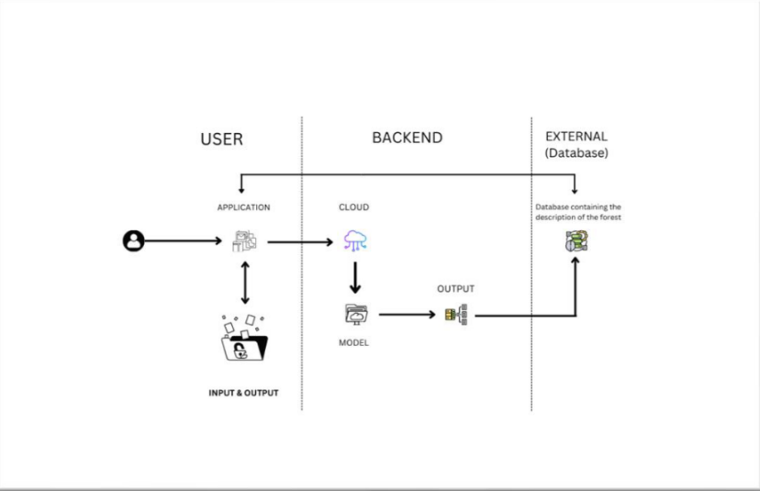

* 1. **SOLUTION & TECHNICAL ARCHITECTURE:**

* 1. **USER STORIES**

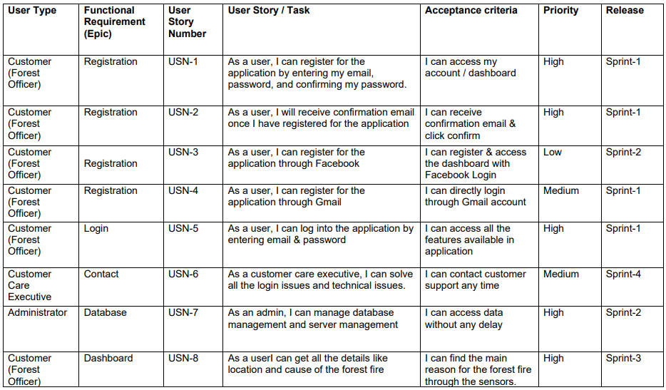

# CHAPTER 6

## PROJECT PLANNING & SCHEDULING

### Sprint Planning & Estimation

|  |  |  |  |  |  |
| --- | --- | --- | --- | --- | --- |
| **Sprint** | **Functional Requirement**  **(Epic)** | **User Story**  **Number** | **User Story / Task** | **Story Points** | **Priority** |
| Sprint-1 | Data Preprocessing | USN-1 | In this process the data completely clean, rescale and ready for the compilation state. | 20 | High |
| Sprint-2 | Convolution Neural Network | USN-2 | Building the model for predicting the images using classification.and it’s predict the images | 20 | Medium |
| Sprint-3 | Video Analysis | USN-3 | The Video method used to  Predict the fire or not. | 20 | High |
| Sprint-4 | Combine the CNN & Video Analysis | USN-4 | The model is predict the video or image the forest is fire or not.and send the SMS to the user. | 20 | High |

* 1. **SPRINT DELIVERY SCHEDULE**

|  |  |  |  |  |  |  |
| --- | --- | --- | --- | --- | --- | --- |
| **Sprint** | **Total Story Points** | **Duration** | **Sprint Start Date** | **Sprint End Date (Planned)** | **Story Points Comple ted (as on Planne dEnd**  **Date)** | **Sprint ReleaseDa te(Actual)** |
| Sprint-1 | 20 | 6 Days | 24 Oct  2022 | 29 Oct 2022 | 20 | 29 Oct 2022 |
| Sprint-2 | 20 | 6 Days | 31 Oct  2022 | 05 Nov 2022 | 20 | 05 Nov 2022 |
| Sprint-3 | 20 | 6 Days | 07  Nov 2022 | 12 Nov 2022 | 20 | 12 Nov 2022 |
| Sprint-4 | 20 | 6 Days | 14  Nov 2022 | 19 Nov 2022 | 20 | 19 Nov 2022 |

### REPORTS FROM JIRA

### 

# CHAPTER 7

# CODING & SOLUTIONING

**7.1 FEATURE**

#### IMAGE PREPROCESSING

##### #1.Importing the ImageDataGenerator Library

**from** tensorflow.keras.preprocessing.image **import** ImageDataGenerator

**import** os**,** types

**import** pandas **as** pd

**from** botocore.client **import** Config

**import** ibm_boto3

**from** io **import** BytesIO

**import** zipfile

**from** tensorflow.keras.models **import** Sequential

**from** tensorflow.keras.layers **import** Convolution2D,Dense,MaxPooling2D,Flatten

**from** ibm_watson_machine_learning **import** APIClient

**from** keras.models **import** load_model

**import** numpy **as** np

**from** tensorflow.keras.preprocessing **import** image

##### #2. DEFINE PARAMETERS FOR IMAGEDATAGENERATOR CLASS

x_train **=** traindata**.**flow_from_directory('/home/wsuser/work/Dataset/train_set',

target_size **=** (64,64),

class_mode **=**'categorical',

batch_size **=** 100,

shuffle**=True**)

##### #3. Applying ImageDataGenerator Functionality to Trainset and Testset

**#a. For Dataset**

**!unzip '/content/drive/MyDrive/ibm/archive (1).zip'**

**#b. For Trainset**

x_train **=** traindata**.**flow_from_directory('/content/Dataset/Dataset/train_set',

target_size **=** (64,64),

class_mode **=**'categorical',

batch_size **=** 100,

shuffle**=True**)

**# c. For Testset**

x_test **=** testdata**.**flow_from_directory("/content/Dataset/Dataset/test_set",

target_size**=**(64,64),

class_mode **=** 'categorical',

batch_size **=** 100,

shuffle**=True**)

#### BUILDING UP A SEQUENTIAL MODEL TO TRAIN THE DATASET.

##### # 1.IMPORTING THE MODEL BUILDING LIBRARIES

#Importing model libraries

**from** tensorflow.keras.models **import** Sequential

**from** tensorflow.keras.layers **import** Convolution2D,Dense,MaxPooling2D,Flatten

##### # 2.INITIALIZING THE MODEL

model=Sequential()

##### # 3.ADDING CNN LAYERS

# a. Adding Convolutional layer

model**.**add(Convolution2D(32,(3,3),activation**=**'relu',input_shape**=**(64,64,3)))

model**.**add(MaxPooling2D(pool_size**=**(2, 2)))

model**.**add(Flatten())

model.add(Flatten())

model.summary()

#### PREDICTION OF DATA.

##### # PREDICTIONS

img **=** image**.**load_img("/home/wsuser/work/Dataset/test_set/with

fire/180802_CarrFire_010_large_700x467.jpg",target_size**=**(64,64))

x **=** image**.**img_to_array(img)

x **=** np**.**expand_dims(x,axis**=**0)

model**.**predict(x)

x_train**.**class_indices

op **=** ['No fire','fire']

pred **=** np**.**argmax(model**.**predict(x))

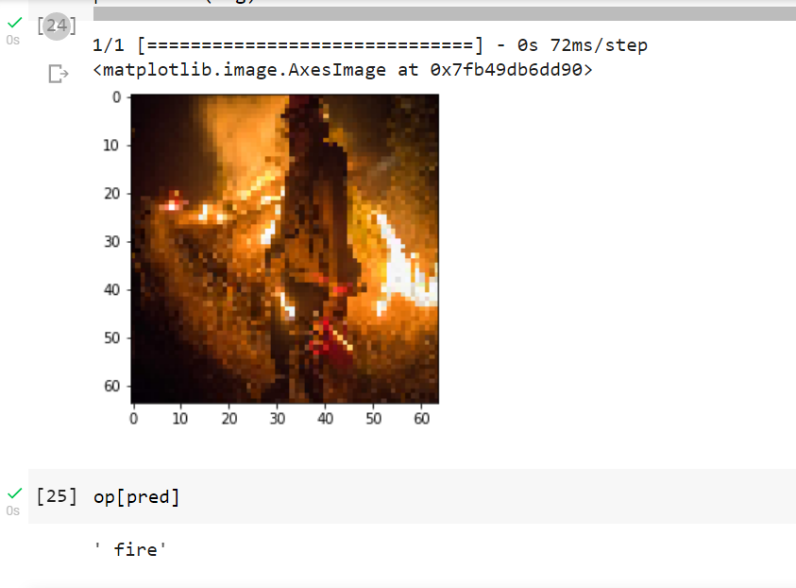 op[pred]

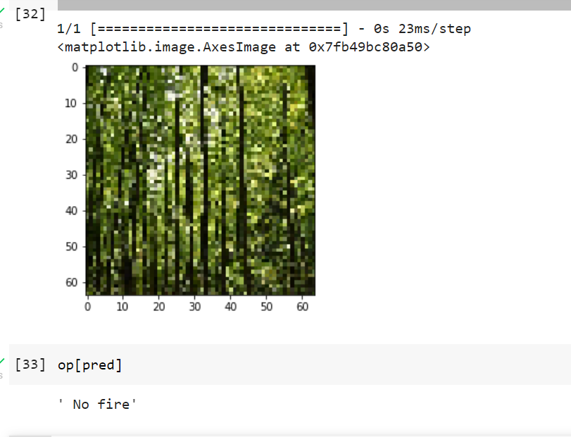

* 1. **FEATURE**

#### CREATION OF TWILIO ACCOUNT

* You must submit an HTTP POST request to Twilio's Message resource in order to send an outgoing SMS message from your Twilio account..
* Replace the placeholder values for account_sid and auth_token with your unique values. You can ﬁnd these in your Twilio console.
  + You’ll tell Twilio which phone number to use to send this message by replacing the from_ number with the Twilio phone number you purchased earlier.
* Next, specify yourself as the message recipient by replacing the to number with your mobile phone number. Both of these parameters must use [E.164](https://www.twilio.com/docs/glossary/what-e164) formatting (+ and a country code, e.g., +16175551212)

We also include the body parameter, which contains the content of the SMS we’re going to send.

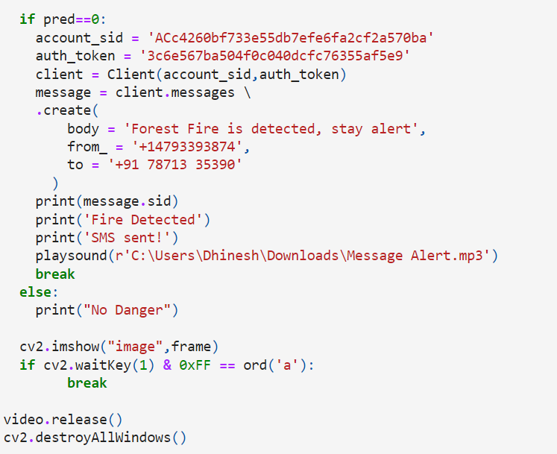

1. **SENDING SMS ALERT**

pip install twilio

pip install playsound

***#******import opencv librariy***

**import** cv2

**import** numpy **as** np

**from** keras.models **import** load_model

**from** twilio.rest **import** Client

**from** playsound **import** playsound

**from** tensorflow.keras.utils **import** load_img, img_to_array

model **=** load_model('FFD.h5')

video **=** cv2**.**VideoCapture(0)

name **=** ["with fire", "forest"]

i **=** 1

**while**(i **<=** 100):

success,frame **=** video**.**read()

cv2**.**imwrite("image.jpg",frame)

img **=** load_img("image.jpg",target_size **=** (64, 64))

x **=** img_to_array(img)

x **=** np**.**expand_dims(x, axis **=** 0)

pred **=** np**.**argmax(model**.**predict(x))

print(pred)

P **=** name[pred]

print (P)

cv2**.**putText(frame,"predicted class = "**+**P, (100, 100),

cv2**.**FONT_HERSHEY_SIMPLEX, 1, (0,0,0), 1)

**if** pred**==**0:

account_sid **=** 'ACc4260bf733e55db7efe6fa2cf2a570ba'

auth_token **=** '3c6e567ba504f0c040dcfc76355af5e9'

client **=** Client(account_sid,auth_token)

message **=** client**.**messages \

**.**create(

body **=** 'Forest Fire is detected, stay alert',

from_ **=** '+14793393874',

to **=** '+91 78713 35390'

)

print(message**.**sid)

print('Fire Detected')

print('SMS sent!')

playsound(r'C:\Users\Dhinesh\Downloads\Message Alert.mp3')

**break**

**else**:

print("No Danger")

cv2**.**imshow("image",frame)

**if** cv2**.**waitKey(1) **&** 0xFF **==** ord('a'):

**break**

video**.**release()

cv2**.**destroyAllWindows()

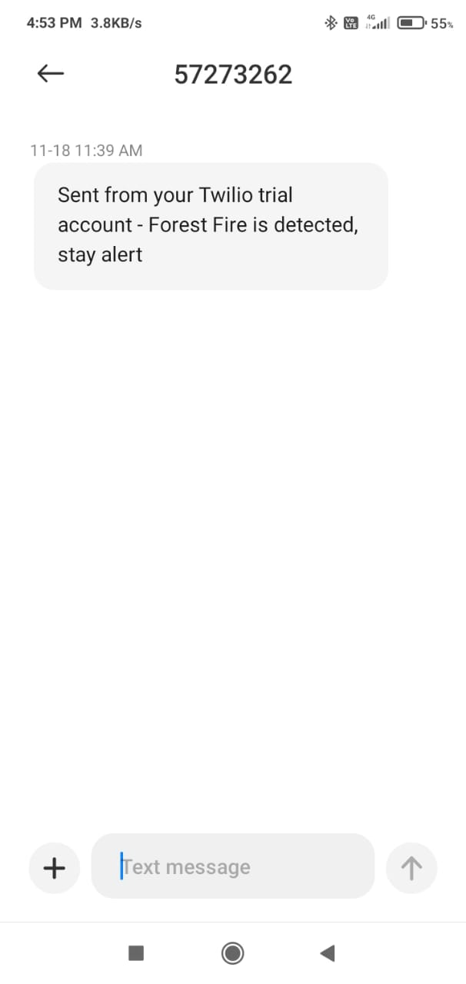

**CHAPTER 8**

**TESTING**

**8.1TEST CASES**

* Test each control on the panel switches and keypads.
* Check the functionality of each visual indication and the alphanumeric displays.
* Battery: MEASURE the system's maximum alert current and quiescent current in accordance with Appendix. Calculate the necessary battery capacity and make sure the installed batteries' nominal capacity is greater than the needed capacity.

* Check to see if the measured currents match those in the baseline data.

**8.2 USER ACEPTANCE TEST**

#### Purpose of Document

* The purpose of this document is to brieﬂy explain the test coverage and open issues of the project at the time of the release to User Acceptance Testing (UAT).

#### Defect Analysis

* This report shows the number of resolved or closed bugs at each severity level, and how they were resolved

|  |  |  |  |  |  |
| --- | --- | --- | --- | --- | --- |
| **Resolution** | **Severity 1** | **Severity 2** | **Severity 3** | **Severity 4** | **Subtotal** |
| By Design | 9 | 5 | 1 | 2 | 17 |
| Duplicate | 1 | 0 | 2 | 0 | 3 |
| External | 3 | 3 | 0 | 1 | 7 |

|  |  |  |  |  |  |
| --- | --- | --- | --- | --- | --- |
| Fixed | 10 | 2 | 3 | 20 | 35 |
| Not  Reproduced | 0 | 0 | 1 | 0 | 1 |
| Skipped | 0 | 0 | 1 | 1 | 2 |
| Won't Fix | 0 | 4 | 2 | 1 | 7 |
| Totals | 13 | 15 | 10 | 25 | 7  2 |

#### Test Case Analysis

This report shows the number of test cases that have passed, failed, and untested

|  |  |  |  |  |
| --- | --- | --- | --- | --- |
| **Section** | **Total Cases** | **Not Tested** | **Fail** | **Pass** |
| Print Engine | 7 | 0 | 0 | 7 |
| Client Application | 53 | 0 | 0 | 53 |
| Security | 2 | 0 | 0 | 2 |
| Outsource Shipping | 4 | 0 | 0 | 4 |
| Exception Reporting | 7 | 0 | 0 | 7 |
| Final Report Output | 3 | 0 | 0 | 3 |
| Version Control | 1 | 0 | 0 | 1 |

**CHAPTER 9 RESULTS**

**9.1 Performance Metrics**

**1.Training the Mode**l

#### Loss or No loss

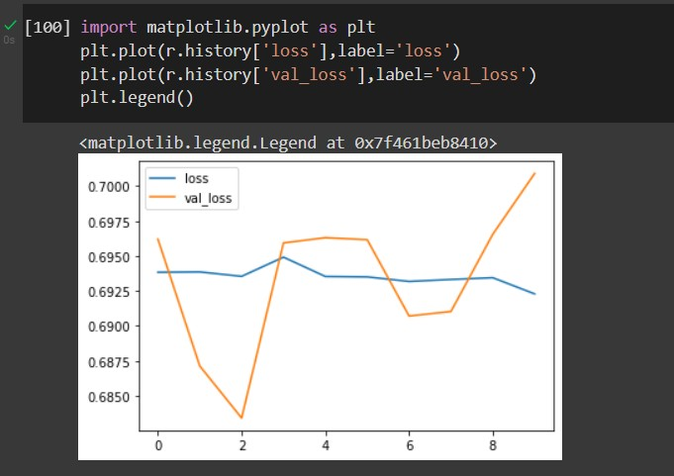

1. **Accuracy Value**

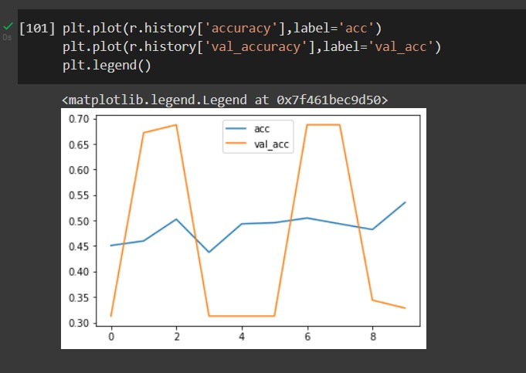

#### Confusion matrix

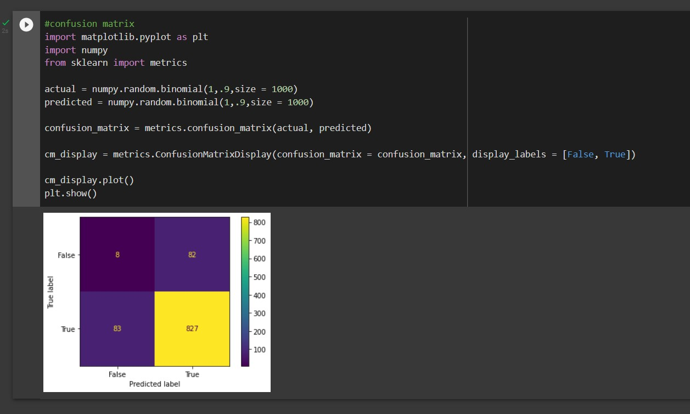

**CHAPTER 10**

**ADVANTAGES & DISADVANTAGES**

**ADVANTAGES**

#### When compared to the current system, the suggested approach identifies forest fires more quickly. It offers improved data collection capabilities.

#### Due to the numerous sensors present, the main benefit is that it lessens false alarms and also has accuracy.

#### It reduces human labour because it operates automatically.

#### The primary goal of our project is to send an alert message to the appropriate user via an app because it is very economical and accessible.

#### The system is straightforward to install, durable, reliable, cost-effective, and fireproof. It can also tolerate extreme temperatures.

#### Additionally, the data from the satellite can be simply and easily decoded at the ground station without the need for specialists.

#### All the parts, including the GPS and temperature sensor, are simple to interface.

#### The GPS coordinates and the approximate temperature are retrieved.

#### The attenuation during the transmission of the signal or the data is minimised because we are using wireless sensor networks.

#### DISADVANTAGES:

* + - The biggest disadvantage is that it has a smaller coverage area, which is caused by electrical .
    - The entire system would crash with even a minor error.

# CHAPTER 11

## CONCLUSION

It was discovered that the suggested approach for detecting forest fires utilising wireless sensor networks and machine learning is an efficient technique that yields more accurate findings. Here, constant analysis and good video monitoring are required to get a more accurate result with the least amount of lag. Any weather, climatic, or geographic condition can be accommodated by this method. Even in areas of the forest with high connectivity and built-in network infrastructure, cameras can be deployed using node deployment. The method is made more effective by the use of IR frame sensors. There is also a novel feature that, when activated, notifies the relevant authorities of the presence of fire.

Therefore, by identifying forest fires, we can prevent loss of life and resources and reduce air pollution, landslides, soil erosion, and CO2 emissions into the atmosphere while conserving deeply rooted trees..

# CHAPTER 12

## FUTURE SCOPE

* + - * The project is currently set up to control two devices, but it could be expanded to control more.
      * With the addition of a voice interactive system facility, it can be further developed.
      * A feedback system that informs remote users of the device's condition can also be included.

**CHAPTER 13**

**APPENDIX**

From tensorflow.keras.preprocessing.image import ImageDataGenerator

traindata = ImageDataGenerator(rescale=1./255,

                              zoom_range=0.2,

                              horizontal_flip=True,

                               rotation_range=260,

                                 vertical_flip=True,

                                fill_mode='reflect',

                                validation_split=0.2)

testdata = ImageDataGenerator (rescale=1./255)

x_train = traindata.flow_from_directory('/content/drive/MyDrive/Dataset/Dataset/train_set',

                                         target_size = (64,64),

                                         class_mode ='categorical',

                                         batch_size = 100,

                                          shuffle=True)

x_test = testdata.flow_from_directory("/content/drive/MyDrive/Dataset/Dataset/test_set",

                                       target_size=(64,64),

                                       class_mode = 'categorical',

                                       batch_size = 100,

                                       shuffle=True)

from tensorflow.keras.models import Sequential

from tensorflow.keras.layers import Convolution2D,Dense,MaxPooling2D,Flatten

model = Sequential()

model.add(Convolution2D(32,(3,3),activation='relu',input_shape=(64,64,3)))

model.add(MaxPooling2D(pool_size=(2, 2)))

model.add(Flatten())

model.add(Dense(300,activation='relu'))

model.add(Dense(450,activation='relu'))

model.add(Dense(500,activation='relu'))

model.add(Dense(2,activation='softmax'))

# compile

model.compile(optimizer='Adam',loss="categorical_crossentropy",metrics=['accuracy'])

# train

model.fit_generator(x_train,steps_per_epoch=len(x_train),epochs=30,

                     validation_data=x_test,

                     validation_steps=len(x_test))

# save the model

model.save('AnimalsDetect2.h5')

import numpy as np

from tensorflow.keras.preprocessing import image

img = image.load_img("/content/drive/MyDrive/Dataset/Dataset/

test_set/forest/0.48007200_1530881924_final_forest.jpg",target_size=(64,64))

x = image.img_to_array(img)

x = np.expand_dims(x,axis=0)

model.predict(x)

x_train.class_indices

op = ['No fire','fire']

pred = np.argmax(model.predict(x))

op[pred]

**GitHub & Project Demo Link**

#### GitHub Link

<https://github.com/IBM-EPBL/IBM-Project-1771-1658412850>

#### Demo Link

<https://1drv.ms/v/s!AvV8cy9hHAd1gQp3iN6F1_zNOMgE?e=CjPexr>